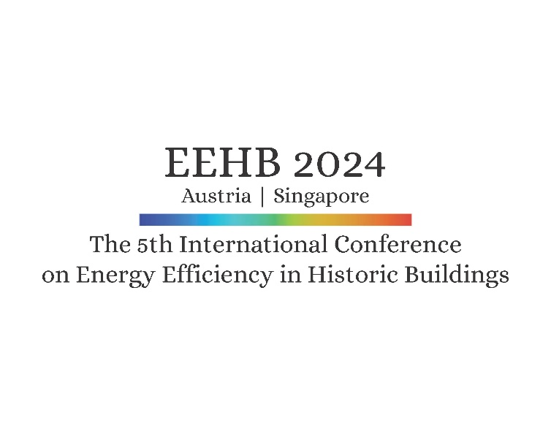Information on traveling   
and accomodation  
Krems-Austria

Link to Krems on Google maps

Link: [Universität für Weiterbildung Krems (Donau-Universität Krems) - Google Maps](https://www.google.de/maps/place/Universit%C3%A4t+f%C3%BCr+Weiterbildung+Krems+(Donau-Universit%C3%A4t+Krems)/@48.4079945,15.5835161,839m/data=!3m2!1e3!5s0x47728448da37528f:0xde4d07af1c3e1f52!4m6!3m5!1s0x47728449162e8263:0x520907d81c8f14b6!8m2!3d48.4081548!4d15.5862305!16zL20vMDRxNTJj?hl=de&entry=ttu)

coordinates: North: 48.408228 East: 15.585036   
 48°24'29.6"N 15°35'06.1"E

Hotels in Krems

Links [www.krems.info/en](https://www.krems.info/en)   
 Mrs. Krumpoeck  
 Phone: 0043 2732 82 676  
 Mail: [krems@donau.com](mailto:krems@donau.com)

We highly recommend to make your reservations *early* (before September)   
 since October is a period of high tourism and start of the academic year.  
  
We have reserved room contingents for   
EEHB 2024 in the following three hotels:

Sunday, 6 October evening to

Wednesday 9 October 2024 morning

Please refer to 'EEHB 2024' when making your booking

to receive special rates and indicate

that you are part of our congress reservation.

arte hotel Modern, located directly at the campus ***

€ 131,- Single person room, incl. breakfast, incl. VAT

€ 173,- Two persons room, incl. breakfast, incl. VAT

[www.arte-krems.at](http://www.arte-krems.at)

Park Hotel Modern, recently renovated, close to city centre ***

1 300 m / 16 min. walk to Campus Krems

€ 115,- Single person room, incl. breakfast, incl. VAT

€ 145,- Two persons room, incl. breakfast, incl. VAT

[www.parkhotel-krems.at](http://www.parkhotel-krems.at)

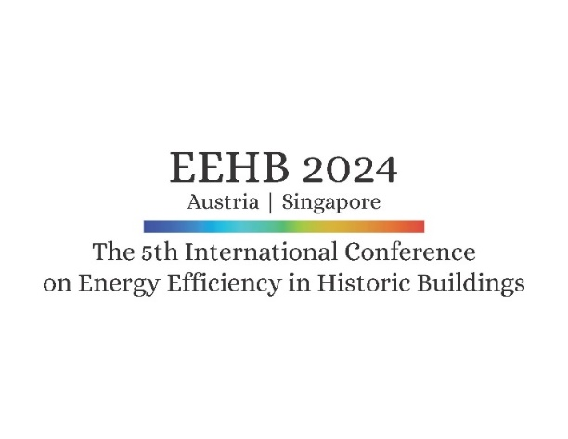

Guesthouse Einzinger 16. century, historic building **

1200 m / 15 min. walk to Campus Krems

€ 56,- Single person room, incl. breakfast, incl. VAT

€ 105,- Two persons room, incl. breakfast, incl. VAT

[www.gaestehaus-einzinger.at](http://www.gaestehaus-einzinger.at)

touristic map **(1)** Venue, Audi Max of University Krems

**(2)** arte hotel

**(3)** Steigenberger Hotel

**(4)** Guesthouse Einzinger

**(5)** Hotel Unter den Linden

**(6)** Park Hotel

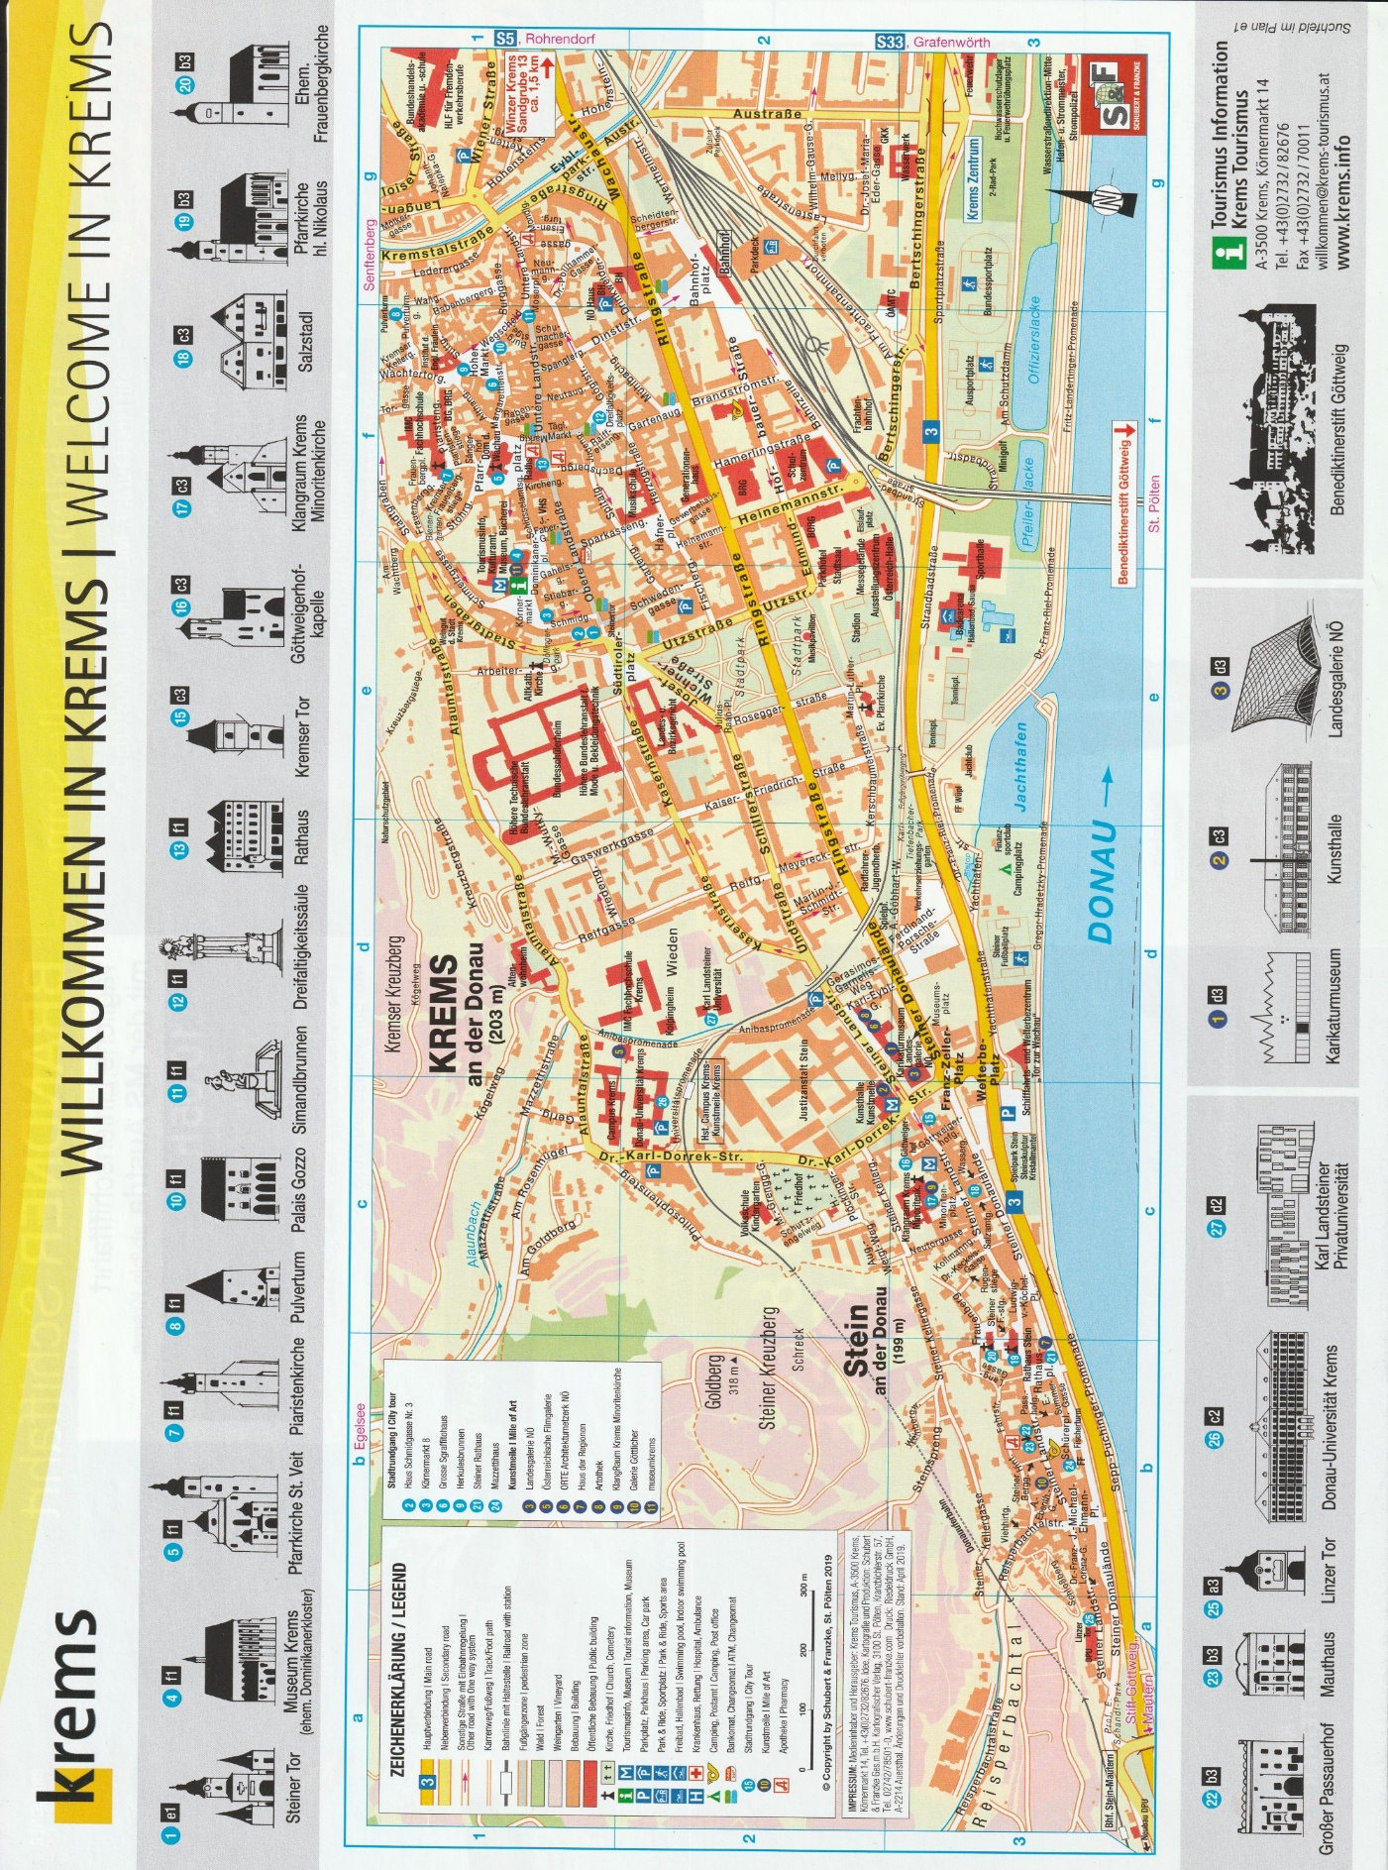

500 Meter

(3)

(2)

(1)

(4)

(5)

(6)

(1)